

School of Computer Science and Engineering
B.Tech in Artificial Intelligence and Data Science

Course Title: Business Intelligence and Analytics
Course Code: B22EH0602
Semester: 6th
Academic Year: 2025-2026

Dashboard Creation Assignment: Predictive Analytics Use Cases

Name: SAGARIKA D S
SRN: R23EH111
AI&DS “B”section

Submitted to,
Prof. Madhumitha Mishra

Title:
Predictive Analytics Dashboard for Marketing Campaign Response

Objective:
The objective of this project is to develop an interactive dashboard that helps stakeholders:
- Identify high-potential customers
- Predict campaign responses
- Improve marketing ROI through data-driven decisions
The dashboard is built using the Bank Marketing Dataset and implemented in Power BI.

Dataset Description:
Dataset: Bank Marketing Dataset (Kaggle)
Key attributes:
- Age, Job, Marital Status, Education
- Contact Type (Cellular/Telephone)
- Campaign interactions (number of contacts, duration)
- Previous campaign outcome
- Target variable: Response (Yes/No)

Page 1: Campaign Overview

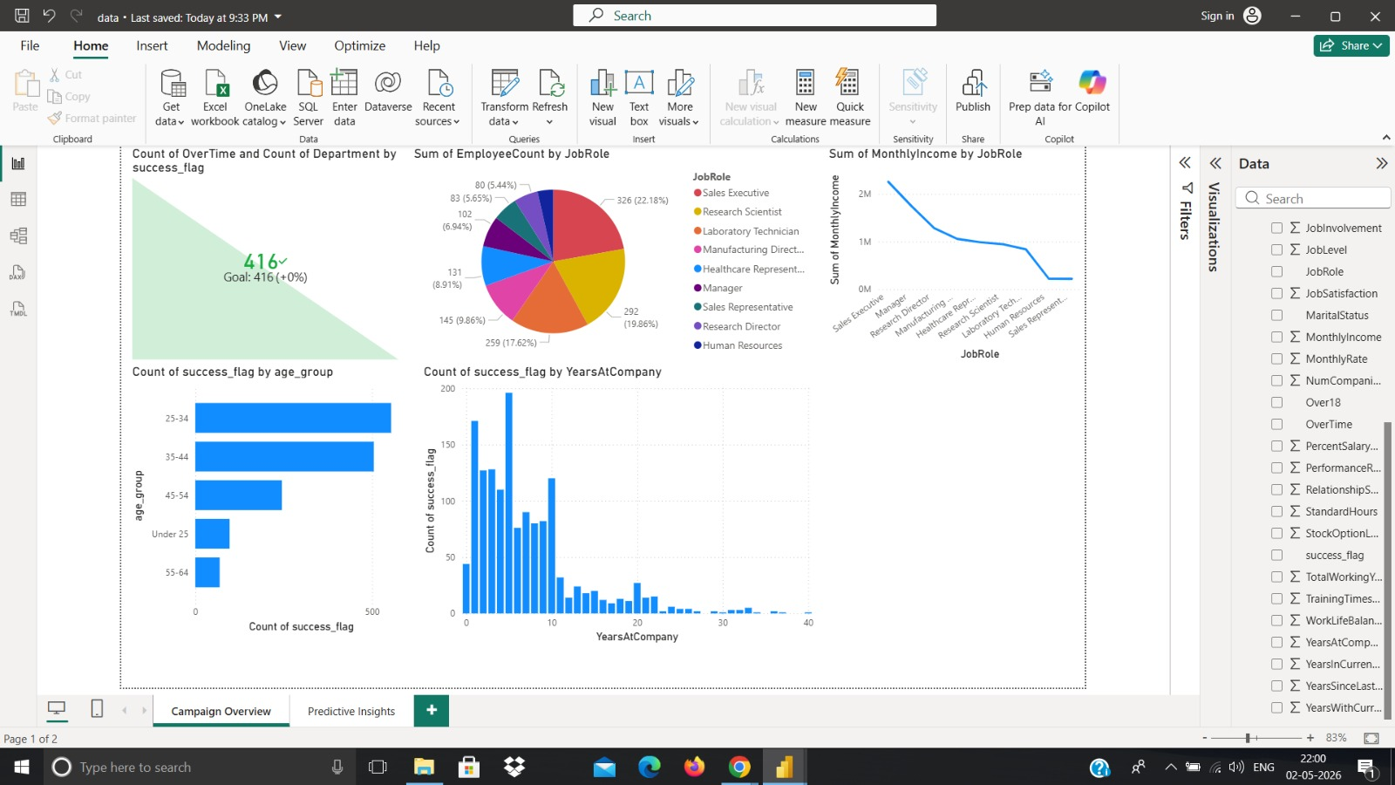

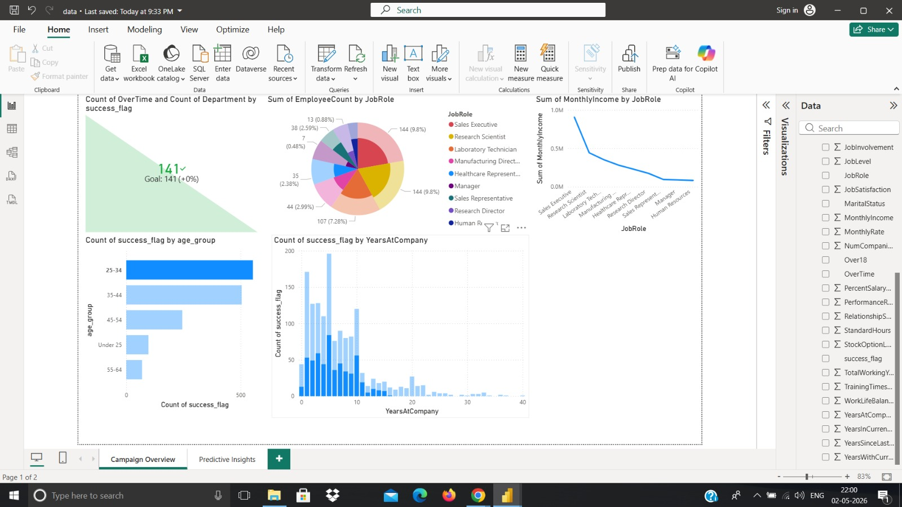
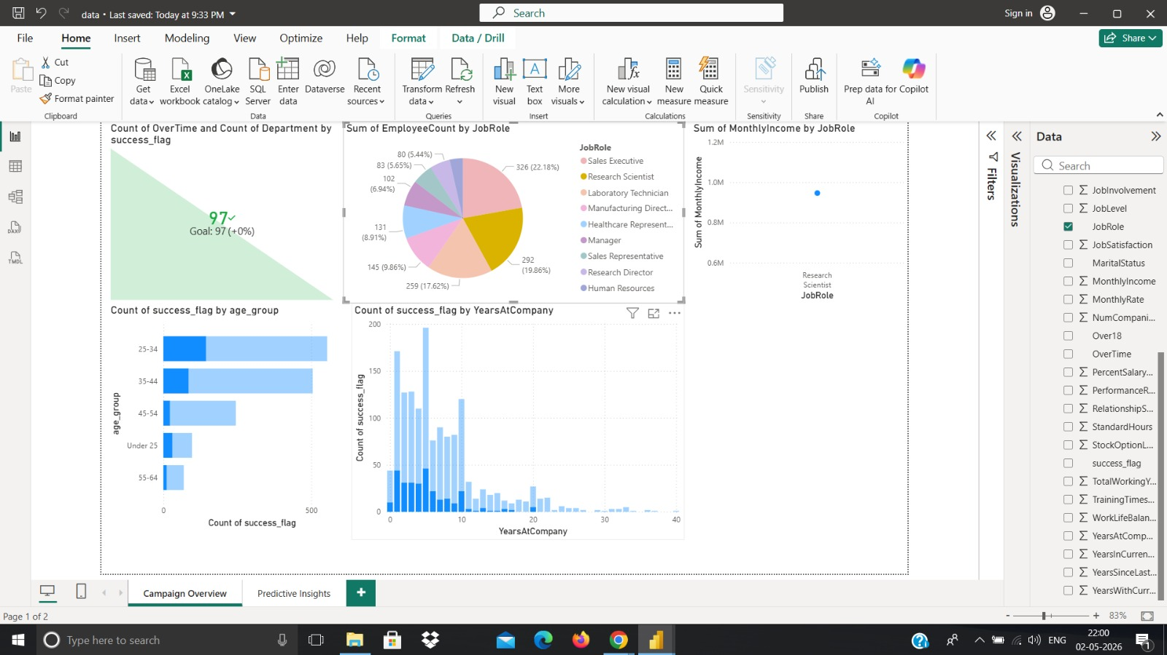

This page focuses on overall campaign performance and success measurement.

Key Visuals:
- KPI Card (Success Count)
Displays total successful responses (416 / 141 depending on filter)
- Pie Chart (Job Role Distribution)
Shows distribution of employees across job roles such as:
  - Sales Executive
  - Research Scientist
  - Laboratory Technician
- Line Chart (Monthly Income by Job Role)
Highlights income variation across job roles
- Bar Chart (Age Group vs Success)
Shows response concentration in:
  - 25–34 (highest)
  - 35–44

Page 2: Predictive Insights
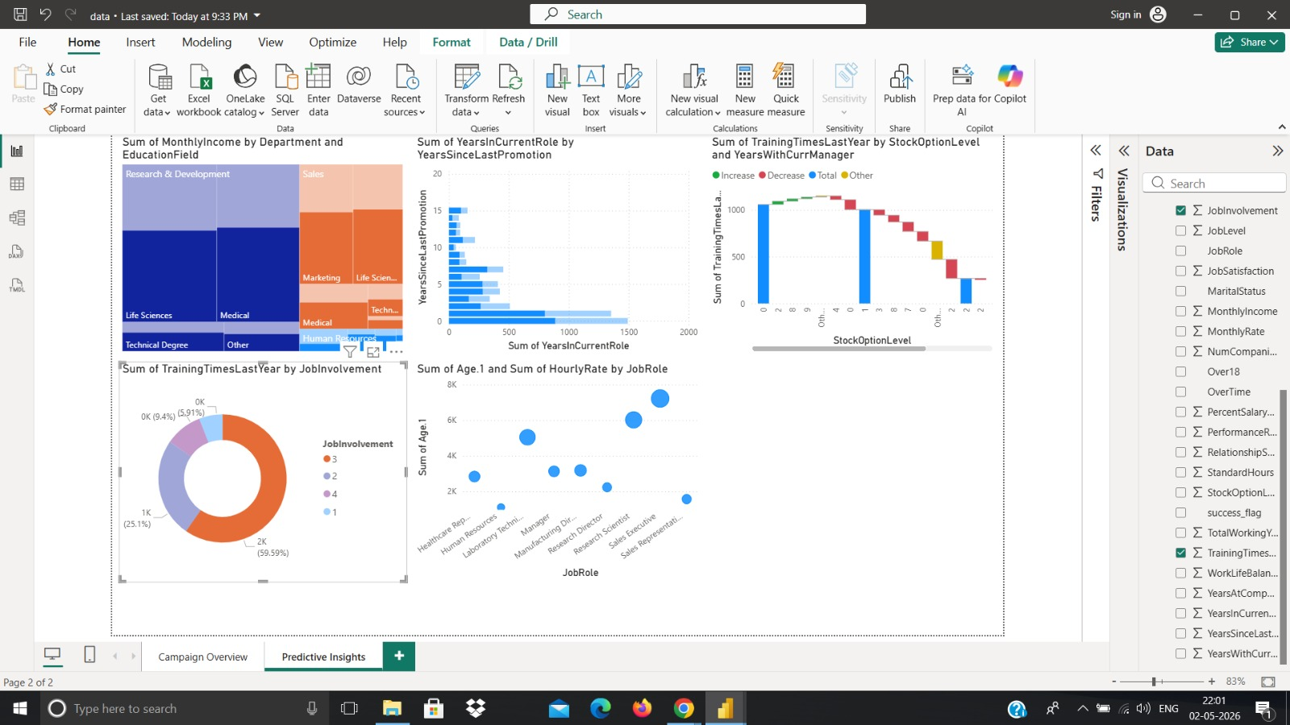

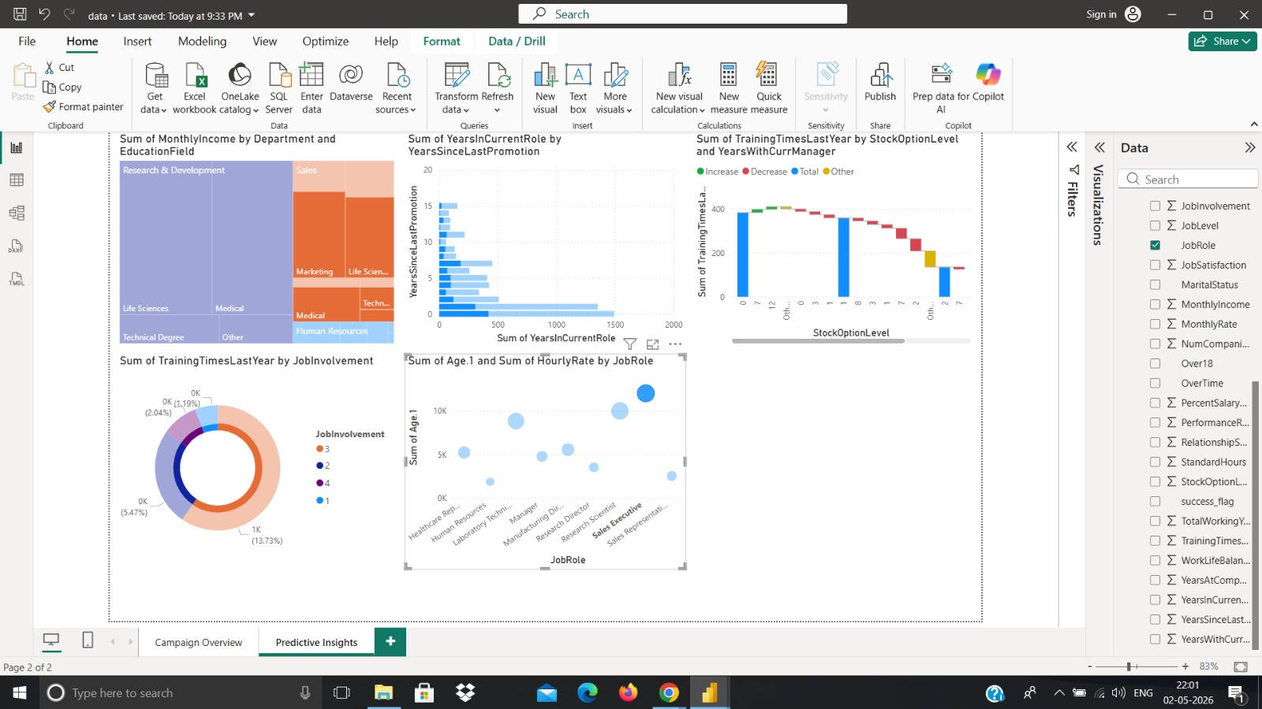
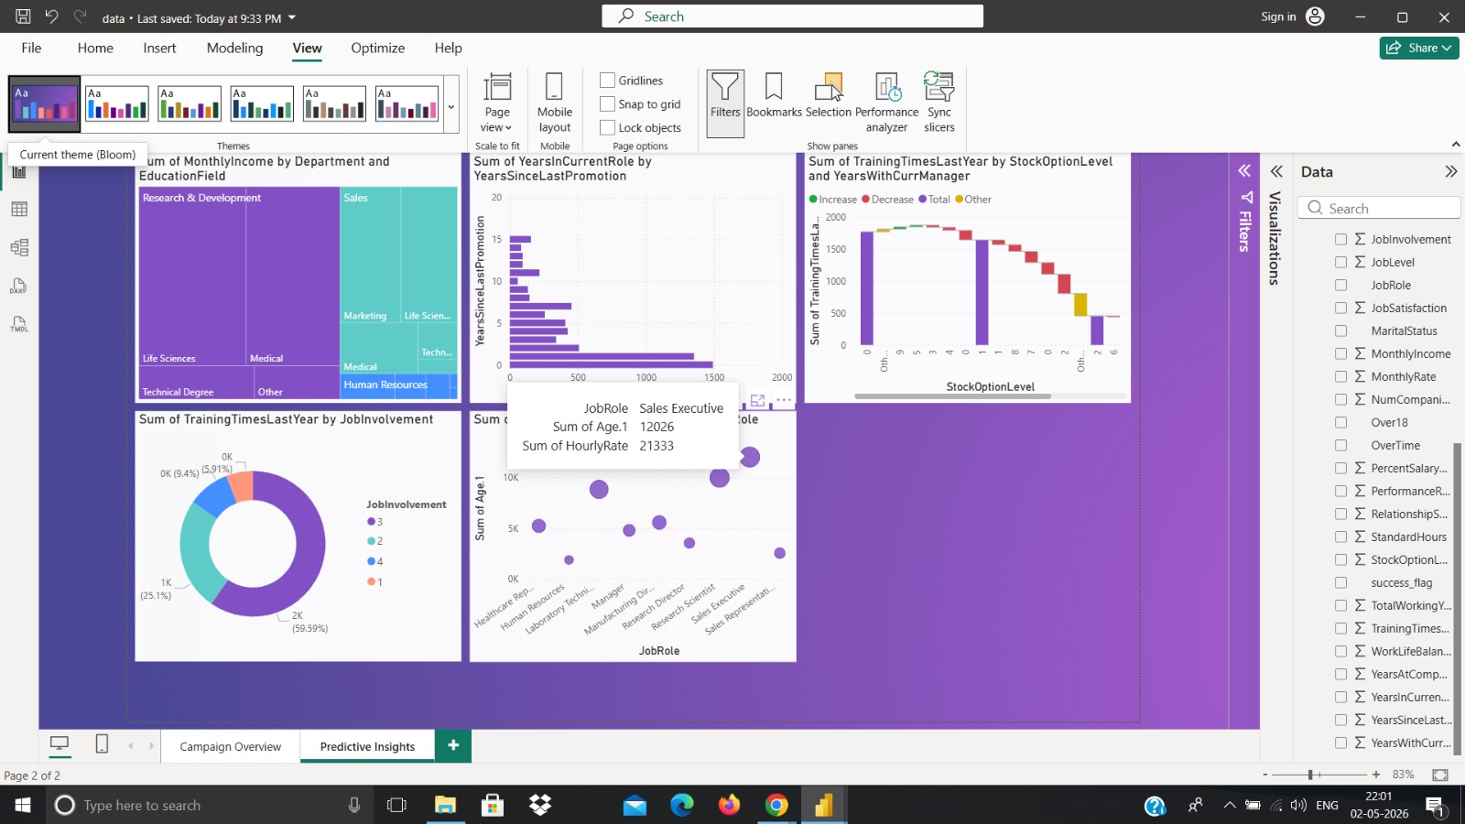
This page focuses on segmentation and prediction-based insights.

Key Visuals:
- Treemap (Department + Education)
Shows income contribution by:
  - Research & Development (highest)
  - Sales & Marketing
- Waterfall Chart (Training vs Stock Option)
Shows impact of training and stock options on engagement
- Donut Chart (Job Involvement)
Majority employees fall under medium to high involvement
- Scatter Plot (Age vs Hourly Rate by Job Role)
Shows relationship between:
  - Experience
  - Compensation

DASHBOARD GOALS MAPPED :

1. Campaign Success Rate
- KPI cards + age group chart show:
  - Majority success from mid-age employees (25–44)
  - Campaign effectiveness varies across segments
2. Customer Segmentation
- Job role
- Age group
- Department
- Education
- Job involvement
Clear segmentation helps identify high-value target groups.

3. Response Prediction Insights
Using:
- Years at company
- Promotion history
- Training & involvement
Helps predict which employees are more likely to respond.
KEY INSIGHTS :
- Highest campaign response comes from employees aged 25–34, followed by 35–44.
- Employees with 0–10 years at the company show the highest engagement.
- Research & Development department contributes the most in terms of income and engagement.
- Employees with recent promotions are more likely to respond positively.
- Higher job involvement strongly correlates with better campaign response.
- Sales Executives and Research Scientists form the largest customer segments.
- Increased training frequency shows mixed impact beyond a point, returns decrease.
- Higher income roles show lower marginal engagement, indicating possible saturation.

BUSINESS RECOMMENDATIONS :
- Target Mid-Age Segment (25–44)
Focus campaigns on the most responsive demographic
- Prioritize Employees with Lower Tenure (0–10 years)
They are more open and responsive to campaigns
- Focus on High-Performing Departments
Invest more in: Research & Development , Sales
- Leverage Promotion Cycles
Run campaigns shortly after promotions for better engagement
- Increase Job Involvement Programs
Boost engagement through: Recognition programs and Participation initiatives Optimize Training Strategy
Avoid excessive training focus on quality over quantity
- Segment Campaigns by Job Role
Customize messaging for: Sales roles and Technical roles
- Use Predictive Targeting
Focus on: High engagement groups and Avoid low-probability segments to save cost

CONCLUSION :
The dashboard successfully demonstrates how predictive analytics can improve campaign performance.
By combining:
- Customer segmentation
- Behavioral insights
- Predictive indicators
the organization can shift from mass marketing to targeted marketing, resulting in Higher response rates , Better ROI and More efficient resource allocation.

